Problem 3

Solution:

To begin with, the number of pivots is initialized as zero. The total number of pivots increases by 1 in each iteration while pivoting. Then the sign is determined depending on even / odd of the total number of pivots. When it is even, sig = 1, otherwise sig = -1. The code is as follows.

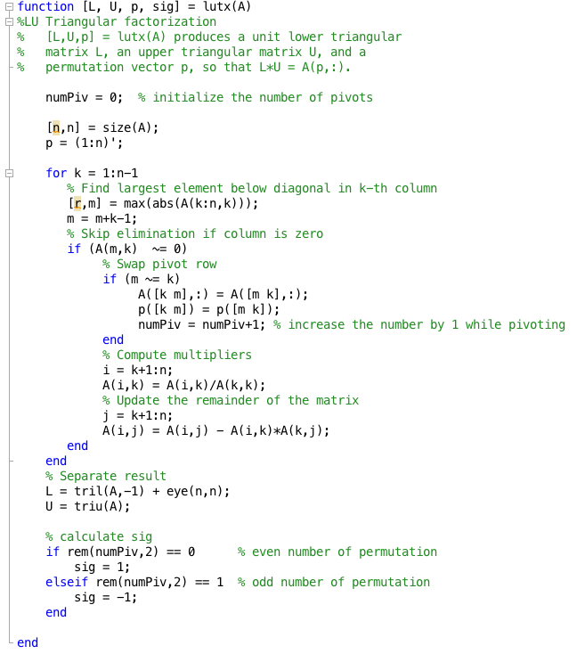

Given LU = PA, we have det(L)det(U) = det(P)det(A). det(L) = 1 since L is a lower triangular matrix. Then det(A) = det(U) / det(P).

The following is the code to calculate det(A):

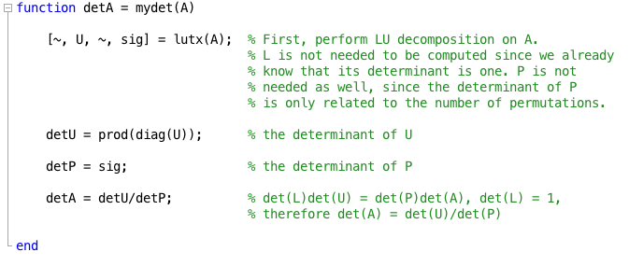

Problem 4

The bar chart below shows the time of operation for the original lutx, modified lutx with for loops and the MATLB built-in function ‘lu’, respectively. It can be seen that using explicit for loop will result in an increase in the time for computation.



